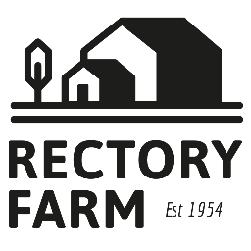
Breakfast Menu
Please order from the counter in the café
Served from 9.30am—11.30am
Toasted teacake with strawberry jam & butter £3.95
Local bacon or sausage bap £6.75
Mushroom & hash brown bap £6.75
Rectory breakfast bap, sausage, bacon & egg £9.00
Little Farmers breakfast, local sausage, bacon, egg, mushrooms, beans, Toast £10.95
Large Farmers Breakfast, 2 x sausage, 2 x bacon, 2 x egg,
mushroom, beans and toast £15.95
Vegetarian Farmers breakfast, hash brown, tomatoes, beans, mushroom, egg, veggie sausage & toast £9.95
Beans on Toast £6.50
Scrambled/Fried Egg on Toast £6.50

Gluten free bread and dairy free options available
Allergens, please speak to a member of staff before ordering if you have any allergies or food intolerances.
Lunch Menu
Allergens, please speak to a member of staff before ordering if you have any allergies or food intolerances.
Please order from the counter in the cafe.
Served from 11.45am-2.00pm
Homemade soup of the day and roll £7.95
Swap roll for homemade cheese scone £8.95
Little Farmers Breakfast £10.95
Large Farmers Breakfast £15.95
Ham, Egg and Chips £11.95
Scampi, Chips and Peas £11.95
Kids size portion of Scampi £7.95
Ciabatta with Mixed Leaf Salad: £7.95
Bacon Brie and Cranberry OR Ham and Cheese OR Brie and Cranberry
Add chips for an extra £1.50
Quiche of the Week with Mixed Leaf salad: £10.95. Available Hot or Cold Add Chips £1.50

